# Database Structure and Considerations

* **Sample Source**
  + **Nasal**
  + **Serum**
  + **Tissue**
* **Data Types**
  + **Cytokines, Chemokines**
  + **Viral Titer**
  + **Symptoms**
    - **Host-species dependent**
    - **Clinical descriptions converted to 0-100 scale**
  + **Immune Cells**
  + **Transcriptomics**
* **Data Details**
  + **Tracking Variance**
    - **Aggregate**
    - **Individual**
  + **Tracking Time**
    - **Dynamic**
    - **Static**
* **Infection Type**
  + **Viral Challenge**
  + **Clinical Study**
    - **Primary**
    - **Contact**
* **Host**
  + **Age**
  + **Gender**
  + **Species**
  + **Pre-Existing Conditions and Individual Variance Factors**

# Voluntary Infection Studies

## Barroso (2005)

### Design

52% men, 48% women. Data does not distinguish (DDND)

18–45, median age 22. DDND

N=18 placebo, 18/18/18/17 in peramivir treatment groups

A/Texas/36/91 (H1N1) and B/Yamagata/16/88

Nasal, Viral Titer, Dynamic, Aggregate, Viral Challenge

### Results

## Calfee (1999)

### Design

100% men.

18-35 age, median 22 (treatment) 20.5 (placebo).

N=8 placebo, n=8 zanamivir treatment.

A/Texas/36/91 (H1N1)

Dynamic Nasal Viral Titer, Aggregated, Viral Challenge. Dynamic 1-10 Symptom Score, aggregated.

### Results

## Fritz(1999)

https://doi.org/10.1086/314938  
Design

100% male.

N=8 placebo, n=8 zanamivir treatment groups.

Median age 23 (placebo), 20.5 (treatment), range 18 – 35.

A/Texas/36/91 (H1N1)

Dynamic, nasal, aggregated with positive standard deviations. Viral titers, clinical symptoms, chemokines, and cytokines are available.

Symptoms

* Oral Temperature
* 0 – 6 Upper Respiratory Symptom Score
* 0 – 5 Systemic Symptom Score
* 0 – 2 Lower Respiratory Symptom Score
* Nasal Discharge Weight

Cytokines: IL-6, TNF-A, IFN-G, IL-10

Chemokines: MIP-1a, MIP-1B, MCP-1, RANTES

### Results

## Hayden (1994)

### Design

100% male

Range 18 – 45.

N=16 (placebo), N=18 (treatment)

Dynamic, nasal, aggregated with standard deviations. Viral titers, 10 symptoms 0 – 4 scale.

### Results

## Hayden (1998)

https://doi.org/10.1172/jci1355

### Design

74% women, 26% men

N=19 (Placebo)

Median age 21, range 19 – 40.

Dynamic nasal aggregated with standard errors of the mean. Nasal-derived viral titers, select cytokines (IL-6, IFN-A, TNF-A, IL-8). Serum derived samples (IL-6, TNF-A).

Symptoms (below) + nasal discharge and oral temperature.

“Symptom assessments were performed by the volunteers twice daily on a four-point scale (0–3 corresponding to absent to severe). The symptoms assessed were nasal stuffiness, runny nose, sore throat, cough, sneezing, earache/pressure, breathing difficulty, muscle aches, fatigue, headache, feverish feeling, hoarseness, chest discomfort, and overall discomfort. The total symptom score for each time point was obtained by adding the individual symptom scores for that particular time point. The individual symptoms contributing to the total symptom score were divided into three subgroups: systemic symptoms (muscle aches, fatigue, headache, and fever), upper respiratory symptoms (nasal stuffiness, earache/pressure, runny nose, sore throat, and sneezing), and lower respiratory symptoms (cough, breathing difficulty, hoarseness, and chest discomfort).”

### Results

## Hayden (1999)

https://doi.org/10.1001/jama.282.13.1240

### Design

Age 18 – 40.

N=13 (placebo), N=56 (multiple oseltamivir treatments)

Dynamic nasal aggregate data. Viral titers, symptoms, and cytokines (IL-6, TNF-A, IFN-G).

### A graph of a drug administration Description automatically generatedResults

## Memoli (2015)

https://doi.org/10.1093/cid/ciu924

### Design

Gender not given

Range 18 – 50

HAI and neuraminidase inhibition (NAI) titers, symptoms (below), serum cytokines (Human Cytokine 17-plex assay).

Nasal Wash viral titer

### Results

## Memoli (2016)

### Design

Broken up by high and low pre-existing HAI titer.

14 female 11 male. 27, 24 – 31 IQR.

19 female 21 male. 27.5 median, 24 – 30.5 IQR.

### Results

## Skoner (1999)

https://doi.org/10.1086/314823

### Design

34 men, 38 women.

Average 31 +- 11 years (range 18 – 50).

N = 38 (placebo), N=34 (rimantadine treatment)

### Results

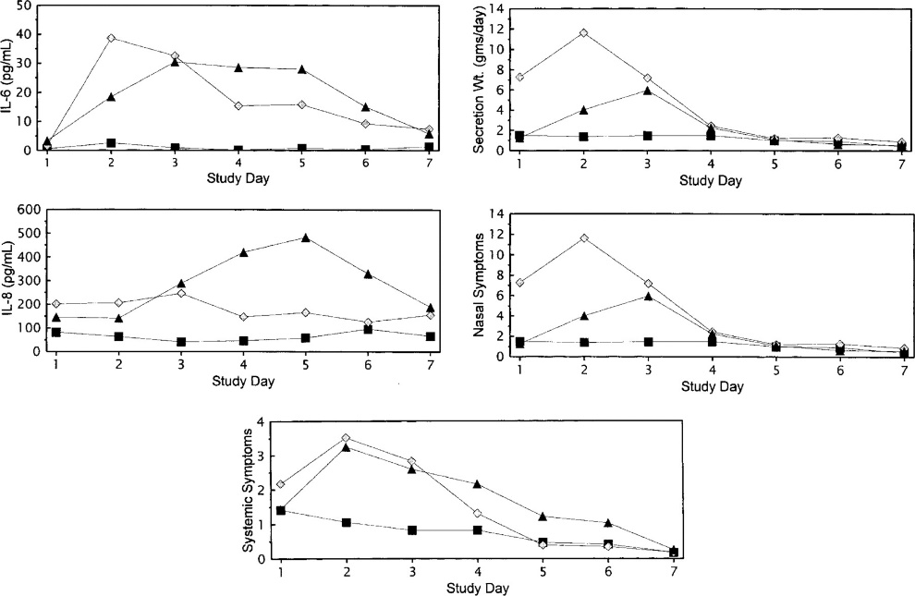

“Average baseline-adjusted interleukin (IL)—6 and IL-8 nasal lavage concentrations, secretion weights, nasal symptom scores, and systemic symptom scores as a function of study day for group without viral shedding (group 1, ▪) and for groups with viral shedding who were treated with placebo (group 2, ▴) or rimantadine (group 3, ◊).”

## Wilkinson (2012)

https://doi.org/10.1038/nm.2612

### Design

N=17 (A/Wisconsin/67/05, H3N2) and N=24 (A/Brisbane/59/07 H1N1).

Age 18 – 45.

### Results

## Ref

### Design

### Results

## Ref

### Design

### Results

## Ref

### Design

### Results

## Ref

### Design

### Results

## Rejected Refs

McClain (2013): WBC only. https://doi.org/10.1016/j.jcv.2013.09.015

Woods (2013): No data. <https://doi.org/10.1371/journal.pone.0052198>

McBride (2017): AUC/Peak only. https://doi.org/10.1128/aac.01154-17